Camp Qld
170 Ski Zone Road
Moogerah Qld 4309





Table of Contents
What to Pack For a Standard 3-Day Camp 5
Teachers’ ‘Don’t Forget’ List 6
Bedding Allocations 7
Other accommodation layout: .
Arrival to Camp 15
First Aid 17
Emergency Numbers 18
Meals 18
Sample 3 day camp menu: 19
Responsibilities for Teachers and Leaders at Camp QLD 21
Emergency Vehicle: 22
Food 22
Food Portions 22
Movie Night 22
Activity Consent Form & Approval 23
Hold Harmless Agreement: 23
Medical Form for school excursions and sporting events 24

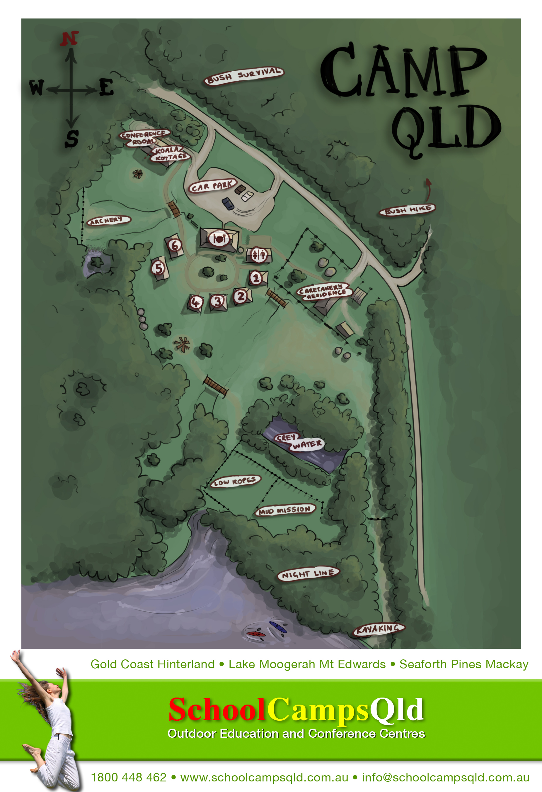

Your Teachers and Leaders School Camp Checklist

Due Date | Task | Completed | Date Completed
On booking | Pay deposit to confirm booking
 | Sign Booking Confirmation – delivered via email
Once deposit is paid | Receive Teachers Guide
 | Organise Students Permission Forms and Payments
 | Receive Sample Program
 | Receive Risk Assessments
21 Days before Camp | We will contact you to answer any questions or make any last minute changes
14 Days before camp | We will email you to confirm:  - Final Numbers  - Dietary Requirements  - Arrival and Depart Time  - Confirmation of Program
 | Ensure your final invoice has been paid by your Accounts Payable Department
After Camp | We will email you a feedback form – Please fill in and press send
 | Please ensure you book your dates for next year for camp

What to Pack For a Standard 3-Day Camp

For longer camps, add an item per day e.g. 5 days – 5 complete changes of clothes…

- 3 complete changes of clothes
- A throwaway set of clothes and shoes
- Underwear and socks for every day plus 1 extra pair of each
- Extra warmer clothes for evenings
- Bathers/swimmers and a beach towel
- 2 pairs of enclosed shoes and an additional ‘wet’ pair to wear for wet activities (Thongs or Crocs are not suitable)
- Sleeping bag, fitted sheet and pillow
- Toiletry bag plus 1 bath towel
- Bath Mat
- Personal medication (to be handed into teachers)
- Sleeping attire
- Torch
- Water Bottle
- Hat
- Sun Screen
- Insect Repellent
- Rain Coat

- PLEASE NOTE – Leadership Under the Star Students, need to supply the following
- Tea Towel
- Cutlery – Knife, Folk & Spoon
- Crockery – Plate, Bowl, Camp Mug
- Sleeping Mat (Foam)

Winter
- Jacket, gloves, slippers
- Plenty of warm clothes
- Inner sheet for sleeping bag or extra bedding
- Beanie
- Scarf
- Warm flannel pyjamas

Teachers’ ‘Don’t Forget’ List

Odd Items that sometimes get forgotten:

- A pillow for every child (get children to sit on pillows in bus)

- Slab of bottled water for any students who forget their water bottle! Very important to keep hydrated during camp.

- A throwaway set of clothes & shoes for the commando/mud course. They may never come clean again!

- Final numbers must be given to Jade Matthews jade@schoolcampsqld.com.au two weeks prior to camp arrival date. These are numbers that will be invoiced and payment is required to be paid before camp. If payment is not received, we cannot guarantee the camp will go ahead.

- If extra students come to camp, a supplementary invoice will be issued. If numbers decrease, the camp will charge based on final numbers given 14 days in advance of camp.

- Two weeks before camp, please email jade@schoolcampsqld.com.au to confirm your numbers and inform us of any dietary requirements such as vegetarian along with medical conditions, allergies & religious diets. We do not cater for likes & dislikes.

- A numbered list of all campers and leaders to be given to School Camps Qld on first day.

- A first-aid kit.

- Sports equipment for free time. e.g. volleyballs, basketballs, cricket set etc.

- Camp QLD address 170 Ski Zone Road, Moogerah

Bedding Allocations – JADE MATTHEWS WILL ADVISE WHICH CABINS YOU ARE STAYING IN. Please check with Jade before you allocate your students.

Please allocate names of students/attendees for Fire and Safety Management:

- Cabin 1 to 4 – Sleep 12
- Cabin 5 – Sleeps 4 teachers/24 Students – Extra beds can be added
- Cabin 6 – Sleeps 3 teachers/24 Students - Extra beds can be added
*Children Under 9 years are recommended not to sleep in top bunks

Cabins must be full (all 12 OR 30 beds occupied) before allocating people to the next cabin given as your allocation. If a room or cabin is not showing on your allocation, please contact us on 1800 448 462.

Cabins 1 - 4 are split with 6 beds on each side of a wall

It is suggested that you fill the bottom bunks first and place older children or adults in top bunks.

Cabin 1 to 4 – Sleep 12 Students – Extra beds can be added

Cabin ONE | Lower Bunks | Upper Bunks
Maximum 12 Singles  Please contact the office if you require more beds | 1. | 7.
 | 2. | 8.
 | 3. | 9.
 | 4. | 10.
 | 5. | 11.
 | 6. | 12.

Notes:

Cabin TWO | Lower Bunks | Upper Bunks
Maximum 12 Singles  Please contact the office if you require more beds | 1. | 7.
 | 2. | 8.
 | 3. | 9.
 | 4. | 10.
 | 5. | 11.
 | 6. | 12.

Notes:

Cabin Three | Lower Bunks | Upper Bunks
Maximum 12 Singles  Please contact the office if you require more beds | 1. | 7.
 | 2. | 8.
 | 3. | 9.
 | 4. | 10.
 | 5. | 11.
 | 6. | 12.

Notes:

Cabin Four | Lower Bunks | Upper Bunks
Maximum 12 Singles  Please contact the office if you require more beds | 1. | 7.
 | 2. | 8.
 | 3. | 9.
 | 4. | 10.
 | 5. | 11.
 | 6. | 12.

Notes:

Cabin Five | Lower Bunks | Upper Bunks
5 Room A  Maximum 6 Singles | 1. | 4.
5 Room A  Maximum 6 Singles | 2. | 5.
5 Room A  Maximum 6 Singles | 3. | 6.

5 Room B  Max 3 Singles - Teachers | 1. | 4.
5 Room B  Max 3 Singles - Teachers | 2.
5 Room B  Max 3 Singles - Teachers | 3.

5 Room C  Maximum 6 Singles | 1. | 4.
5 Room C  Maximum 6 Singles | 2. | 5.
5 Room C  Maximum 6 Singles | 3. | 6.

5 Room D  Maximum 12 Singles | 1. | 7.
5 Room D  Maximum 12 Singles | 2. | 8.
5 Room D  Maximum 12 Singles | 3. | 9.
5 Room D  Maximum 12 Singles | 4. | 10.
5 Room D  Maximum 12 Singles | 5. | 11.
5 Room D  Maximum 12 Singles | 6. | 12.

Cabin 6
6 Room A  Maximum 6 Singles | 1. | 4.
6 Room A  Maximum 6 Singles | 2. | 5.
6 Room A  Maximum 6 Singles | 3. | 6.

6 Room B  Max 3 Singles - Teachers | 1.
6 Room B  Max 3 Singles - Teachers | 2.
6 Room B  Max 3 Singles - Teachers | 3.

6 Room C  Maximum 6 Singles | 1. | 4.
6 Room C  Maximum 6 Singles | 2. | 5.
6 Room C  Maximum 6 Singles | 3. | 6.

6 Room D  Maximum 12 Singles | 1. | 7.
6 Room D  Maximum 12 Singles | 2. | 8.
6 Room D  Maximum 12 Singles | 3. | 9.
6 Room D  Maximum 12 Singles | 4. | 10.
6 Room D  Maximum 12 Singles | 5. | 11.
6 Room D  Maximum 12 Singles | 6. | 12.

Cabin 1 to 4

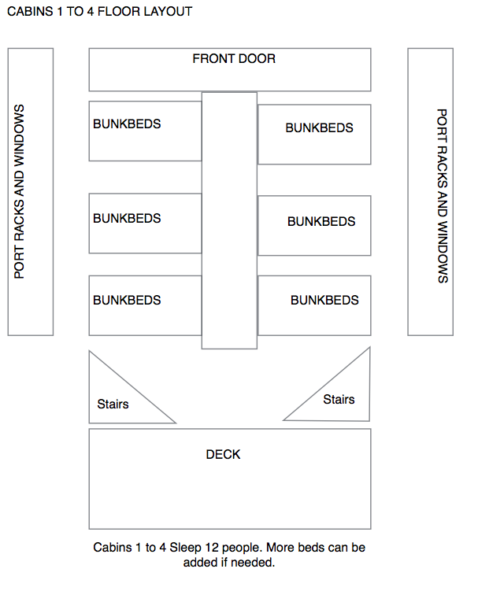

Cabin 5 and 6

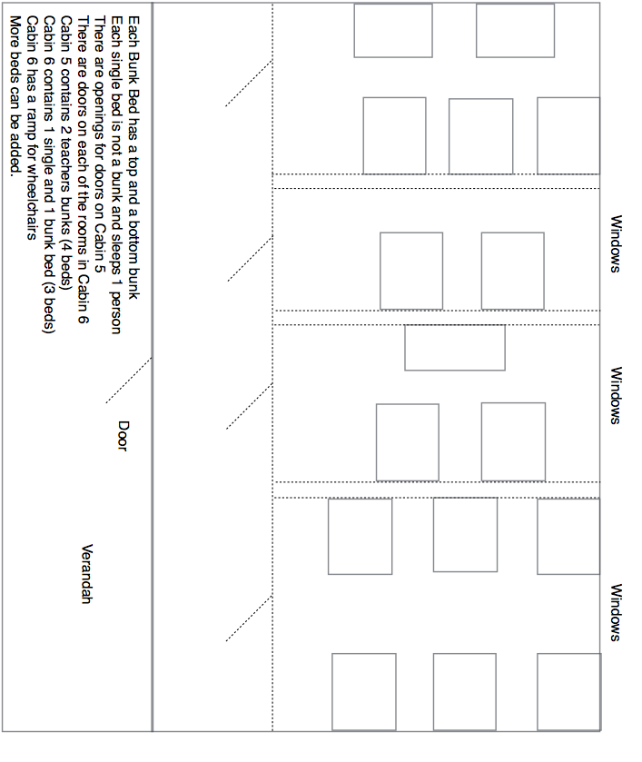

Camping Allocations – Leadership Under the Stars

Tent No: | Student Names
Maximum 9 Singles  Please contact the office if you require more beds | 1.
 | 2.
 | 3.
 | 4.
 | 5.
 | 6.
 | 7.
 | 8.
 | 9.

Tent No: | Student Names
Maximum 9 Singles  Please contact the office if you require more beds | 1.
 | 2.
 | 3.
 | 4.
 | 5.
 | 6.
 | 7.
 | 8.
 | 9.

Please photocopy this page if you require more tents. Each is to be filled before moving onto the next.

Arrival to Camp
On arrival, please remain on bus for Camp Co-Ord welcome -There is plenty of room for buses to turn around.

You will be met in the car park by your Camp Co-ordinator. Please have the students remain on the bus at his stage.

Your Camp Co-ordinator will introduce themselves to you and the students and instruct them ON the bus you may then proceed from the bus. All students must collect their bags and proceed to the grassed area awaiting further instructions.

Students will then be allocated to their cabins using the bedding allocation list you have previously prepared – Please hand Bedding Allocation list to Jo

Cabins will be allocated depending on numbers in your group.
You will not have access to all of the cabins if your numbers fall below 96.

The cabins are as follows:

Cabin 1 to 4: 6 bottom bunks / 6 top bunks in each cabin
TOTAL: 48 IN 4 CABINS
Cabin 5 to 6: 12 bottom bunks / 12 top bunks in each cabin
TOTAL: 48 IN 2 CABINS

TOTAL CAPACITY: 96 students – If you need extra beds please advise as they can be added.

Please check with Jade Matthews on 07 5543 8076 which cabins are assigned to your group before you write up your bedding allocation.
Once students have deposited their bags to their rooms, they are required to sit in the recreation hall or the grassed area in their teams. Depending on numbers, you may need to split your group into 4 teams or 6 teams. Please check with Jade Matthews on 07 5543 8076 regarding how many teams you will need to allocate prior to arrival.
Your activities program will indicate the number of teams you require.

First Aid
It is the responsibility of teachers / group leaders to provide First Aid to any children or students who need it. Facilitators do carry small First Aid Kits to all activities and act in accordance with the legal requirements set out by Queensland Ambulance guidelines.
However, teachers / group leaders are ultimately responsible for administering First Aid. There is ICE available at the kitchen.

Facilitators and instructors are not permitted to leave their activity area and so a teacher or group leader would need to get the ice and make the emergency phone calls required in line with school protocol and procedure.

Facilitators carry mobile phones at all times and phones are located in the kitchen emergency phone calls.
Telstra Mobile has full coverage at Lake Moogerah. Optus and Vodafone do not.

Do not rely on mobile phones to receive calls. There is also an after hours caretaker who can be reached for an emergency or staff are located in the staff house also for emergencies – 0404 447163

Groups are required to bring a vehicle for emergency use
And are also required to bring and use their own first aid kits.
Permanent School Camps Qld staff holds current First Aid Level 2 qualifications.
SCQ staff will be responsible for the technical safety during activity sessions run by SCQ.
An area has been set aside for first-aid in the dining room. A School Camps Qld first-aid kit is available for emergency use upon request. Groups will be billed for bandages etc.
A copy of the Emergency Procedures is available on the main noticeboard and in every hut. There is a telephone for emergency calls in the kitchen. Emergency numbers are pinned to the wall near the telephone.

Emergency Numbers
Police/Fire/Ambulance | 000
Mobile call Police Fire ambulance | 112
Beaudesert Hospital | 5541 1411
 | 5545 2788
SES | 5540 5131
Poisons Information | 13 11 26
Boonah Police Station | 5463 3999

Meals

Meals
At Camp Qld we like to involve the kids at meal-time preparation so they feel a sense of responsibility.

Duty Groups are in line with activity groups. During each meal, duty groups will be required to be at the Recreation Room Kitchen 30 minutes before scheduled meal times. Duty Groups will then have responsibilities to get the dining area ready.

Duty Groups will also eat before other students. If you are having activities, duty groups will fall in line with these. If no activities, please divide your group into smaller groups of 12 to 15 students.

It is normal for duty groups to take some time in washing and drying and cleaning the hall. However, as the supervising teacher, you must motivate and encourage the students to be quick and thorough. This activity is as important as all the others on camp. It teaches, consequences, responsibility and team work.

If you prefer not to have DUTY GROUPS, there is an extra cost for wait-staff service. This depends on numbers. Please advise if this is the case.

Supper
Supper is provided free of charge. Hot or Cold Chocolate or Milo and biscuits will be available for you to have at your leisure.

Coffee and Tea Station
A coffee and tea station is available for teachers and leaders only to use at their leisure. Please do not allow children or students to use this facility.

Sample 3 day camp menu:

Morning Tea
Choc Chip Cookies and a ‘Help Yourself’ Fruit Bowl

Lunch
Traditional Hamburgers served with Pineapple, Beetroot, Cheese, Caramelized Onions, Crispy Salad and Condiments

Afternoon Tea
Vegemite and Cheese Puff Pastry Scrolls and a Fruit Platter

Dinner
Spaghetti Bolognaise served and Garlic Bread
Vanilla Ice Cream and Toppings

Supper
Hot Chocolate and Biscuits

Breakfast
Choice of Cereals, Crispy Bacon and Scrambled Eggs on Toast, and Juice

Morning Tea
Homemade Muffins and a ‘Help Yourself’ Fruit Bowl

Lunch
BLT’s Sandwiches

Afternoon Tea
Jam Puff Pastry Scrolls and Fruit Platter

Dinner
Chicken Schnitzel, Creamy Potato Bake served with Garden Vegetables
Two Fruits and Custard

Supper
Hot Chocolate and Biscuits

Breakfast
Selection of Cereals, Toast, Fluffy Pancakes served with Maple Syrup

Morning Tea
Gruffalo Slice and a Fruit Platter

Lunch
Sausage Sizzle on a Hot Dog Bun served with Caramelized Onions, Salad and Condiments
* Chilled water available all day. Cordial served with dinner only. Continuous Tea and Coffee for Teachers only.
Menu subject to change without notice

Dietary Requirements

Fresh fruit is always available for special dietary guests – please request from the Cook / Kitchen team if required.

Soya Milk and other dietary requirements are available. However, it is highly recommended that students and teachers bring along snacks and their preferred brands of pasta, bread etc. As the brands we use may not be their preference.

Guests Name | Vegetarian  A meal free of any meat product. | Vegan  A meal free of ANY animal derived products  OVO – eats eggs and no dairy  LACTO eats dairy and no eggs  LACTO OVO eats eggs and milk | Gluten, Wheat Free & Celiac  A meal free of any wheat & gluten | Dairy Free / Lactose intolerant  No dairy used in meals | Peanut Allergy  Please indicate if the guest carries and Epi Pen
Please indicate if the guest has any other food intolerance plus any other requirements we may need to know.

Responsibilities for Teachers and Leaders at Camp QLD

Lead Teacher/Group Leader is responsible for collecting and bringing consent forms, medical forms & bedding allocation for fire register. He/she must enter into the School Camps Qld Illness/Injury registers any illnesses or injuries that occur whilst at camp. A list of names of all campers must be handed to School Camps Qld staff on arrival.

There must be one teacher/group leader with every activity group of children. The recommended national ratio is 1 teacher to 15 children.

Teachers on Swimming activities are required to hold a Bronze Medallion in Lifesaving. This is recommended by the Education Department and is on all Risk Assessment Documentation.

As the camp is situated on a lake, School Camps Qld and Camp Qld are not responsible for any supervision of swimming. Your leaders and teachers are responsible at all times for swimming supervision of your students and campers. A life-guard is not provided unless specifically requested and is an added cost.

One teacher/group leader must supervise the duty group of children that set up and clean up after meals.

If you prefer not to clean up a cleaning fee will be invoiced to the school for cleaning.

This also applies to toilets and showers and camp clean up. If the camp is not left in the cleanliness and standard that you arrived in, a cleaning fee will be charged.

Teachers/group leaders are responsible for children during all non-activity time. Eg free time, meal times, night-time.

Teachers are also responsible for students throughout the entire camp. Especially in respect to their behaviour and safety. This includes the students listening ability. It is not the responsibility of the facilitators or SCQ leaders to ensure the students are behaving respectfully. At times, we may need to say things to the students to get them to listen. However, you know your students better than we do. So please, keep your students respectful and organised.

School Camps Qld facilitators do hold First Aid Qualifications. However, teachers are required to administer first aid in all cases.

While School Camps Qld Program Staff will be responsible for the technical safety of campers when they are instructing an activity it is the responsibility of teachers/group leaders to ensure that discipline is maintained.

Teachers and supervisors are welcome to participate in activities. However, please beware that if any person is required to leave an activity, the teacher/supervisor may need to leave with them. For example in case of an emergency or first aid requirement (getting ice etc)

In situations where School Camps Qld Program Staff are working one to one with an individual student e.g. abseil, pamper pole, the teacher/group leader is responsible for the rest of the group.

Teachers / group leaders are also responsible for all swimming supervising of children. Though a facilitator may be present during a swimming activity (such as the Adventure Hike), teachers and group leaders are responsible for safety of all children and young adults during swimming.

It is recommended that shoes be worn during all swimming events at natural rock pools. It is also not recommended to allow children, students and young adults dive or jump in any swimming holes.

Emergency Vehicle:
It is recommended that at least one teacher brings a vehicle to camp in case of emergencies.

Food

We do cater main meals for vegetarian, dairy/lactose free and gluten free diets however please ask students and teachers with special diets to bring along snacks and preferred foods with them to camp that are suitable to their dietary requirements.

I would also recommend that other special diets e.g. food coloring intolerances, low sodium diets and fussy eaters also bring food along with them to the camp to guarantee their dietary requirements are fulfilled to provide sustenance during very physical activities.

We endeavor to provide a high standard of nutritious meals for students and teachers alike. However we would not like anyone to go without.

Our chef is more than happy to prepare the food for them which we will keep it in our cool room for the duration of the camp.

Food Portions
Food is an essential aspect of our camps and we like it to taste wonderful, be filling and healthy for all of the activities your students will be participating in.

Therefore, we portion the food accordingly. There are always seconds and if any student is hungry or if any of your students are not eating for one reason or another, please report to the kitchen ASAP so that they can have more to eat.

A lot of students will not eat their full meals. I.E. their vegetables and salad and fruit. It is of great importance that as a teacher, you can encourage your students to eat all of their meals. The activity program is very energetic and requires a lot of carbohydrates and fresh healthy foods to sustain the energy required to complete the program.

All groups are different in their eating behaviours. Some camps will have loads of leftovers and others will eat everyone out of house and home! We love both and want both to be happy with their dining experience.

If a student says they are hungry, PLEASE come and tell us immediately. We cannot solve a challenge that is unknown to us.

Movie Night
Please BYO movies for movie night as different schools have different requirements

Activity Consent Form & Approval
by Parents or Legal Guardian
This form is to give consent for school excursion activities whether staying overnight or day visiting. Activities may include: Archery / Swimming / Mission Mud Course/ Bush Survival / Outback Art / Star Warts Night Game / Big Screen Movie Night – G rating movies only – BYO Movies / Bonfire night / Orienteering / Games and Initiatives / Adventure Hike an / Bush Walking / Kayaking / Short transport on a commercially licensed coaster for transfers if needed.

First name of participant and middle initial _______________ Last name ________________

Address _______________________ City_________________State _____ P/C _________

Email Address ______________________________________________________________

Birth date (month/day/year) ____/____/______ Age during activity ___________________

Has approval to participate in __________________________________________________
(Name of activity, orientation flight, outing trip, etc.)

From ______________ to ______________. (Date) (Date) o Without restrictions o Special

considerations or restrictions: _________________________________________________

Hold Harmless Agreement:
I understand that participation in School Camps Qld activities involves a certain degree of risk and can be physically, mentally, and emotionally demanding. I have carefully considered the risk involved and have given consent for myself or my child to participate in this activity. I also understand that participation in this activity is entirely voluntary and requires participants to abide by applicable rules and standards of conduct. I release School Camps Qld, the local council, the activity coordinators, and all employees, volunteers, related parties, or other organisations associated with the activity from any and all claims or liability arising out of this participation. I also allow outdoor group photos to be taken of my child and used for other school promotional purposes.
In case of emergency involving my child, I understand every effort will be made to contact me. In the event I cannot be reached, I hereby give my permission to the medical provider selected by the adult leader in charge to secure proper treatment, including hospitalisation, anesthesia, surgery, or injections of medication for my child. Medical providers are authorised to disclose to the adult in charge examination findings, test results, and treatment provided for purposes of medical evaluation of the participant, follow-up and communication with the participant’s parents or guardian, and/or determination of the participant’s ability to continue in the program activities.
Participant’s signature________________________________________________________

Date ____________ Parent/guardian printed_______________________________________

Parent/guardian signature __________________________________ Date ____________
Area code and telephone number (best contact and emergency contact) Email (for use in sharing more details about the trip or activity)
Medical Form for school excursions and sporting events
STRICTLY CONFIDENTIAL
This information will enable excursion organisers to provide health care for your child.
Teaching from your school Staff will provide immediate first aid and contact an ambulance as required following the HLS-PR-002 First Aid policy.
Student details
Student’s name: |  |  |  |  |  |  | Date of birth:
Parent/s full name:
Address: |  |  |  |  |  | Postcode:
Telephone number: | Home:
Mobile:
Email:
Name of family doctor: |  |  |  |  | Telephone number:
Medicare number:
Health conditions and other injuries
Is your child subject to □ seizures/ epilepsy, □ fainting, □ diabetes, □ asthma, □ severe allergies/anaphylaxis □ heart problems including heart murmurs or □ any other condition that may affect his or her safety or ability to fully participate during the excursion/sports event?
Do you have an injury or condition which is likely to be aggravated by sporting competition? □ Yes □ No
List/describe health conditions/injuries if applicable including any recent illness
If you answered “yes”, you may be required to provide an Individual and Emergency Health Plans to the school if the school does not have a copy (discuss with school administration as additional information may be required to support the management of the health issue away from school)

Is your child allergic to:  (Please tick) |  |  |  |  | Please give details:
Any food
Any insect stings
Any medications
Other
Date of last tetanus vaccination:
Medication
Parent/s are requested to make arrangements with the teacher-in-charge for the safekeeping and handling of prescribed medications and equipment prior to the excursion/sports event.(All medication will be administered according to the HLS-PR-009 Administration of routine and emergency medication policy)
Is your child presently taking tablets and/or other forms of prescribed medication? |  |  |  |  |  |  |  |  |  | Yes |  |  | No
If "yes", complete the Authority to Administer Medication form below
Does your child wear:
□ Glasses Contact lenses □ soft □ hard □ prosthetics / Protective equipment - □ mouthguard □ orthotics
Other please specify:
Other information
Please provide any other information about your child which will enable the organisers of the excursion/sports event to provide better care for your child. e.g. special dietary requirements, blood transfusions (i.e. medical/religious reasons)
Excursion/Sports Event Consent : I , give consent for teachers/staff involved in the school/sport activity to provide basic first aid as required, contact an ambulance, who will determine any additional emergency response required. I understand that all reasonable attempts will be made to contact me in the event of any emergency.
Signature of Parent: Date:

School Name:
Student Name: Date of Birth / / Allergies: Year Level:______________
Please list all medications that your child requires during school hours. Please also list medication administered at home and any emergency medications.
Name of medication | Strength (eg 10mg) | Dosage (eg 1 tablet) | Route (eg oral, via PEG) |  | Time/s to |  |  | Time/s given at home | Other useful instructions or information
 |  |  |  |  | be given at camp |  |  | Time/s given at home | Other useful instructions or information

For Medication Form Page 27:
Parent/Carer Print name:
Signature:
I hereby request that school staff administer the necessary medication to my child while at school. I agree to notify the school, in writing, if there are any changes in the above medication.
Authorising Practitioner Print name:
Date: / / Phone:
Date: / / For school staff to administer over-the-counter medication, authorisation is required from a medical practitioner
The following points are for security and safety purposes, and are requirements of the Health (Drug and Poisons) Regulation 1996 (Qld).
- The parent notifies the school in writing to administer medication. This may include written guidelines from the prescribing health practitioner, including potential side affects or adverse reactions.
- Provide medication in original pharmacy labelled container to the camp.
- Ensure medication is not out of date and has an original pharmacy label with the student’s name, dosage and time/s to be taken.
- Notify the school in writing when a change of dosage is required. This instruction is to be accompanied by a letter from a prescribing health practitioner or change of label from a pharmacist.
- The student has received a dose at home without ill effect.
- Advise the camp in writing and collect the medication when it is no longer required on camp.
- Where parents are working with a prescribing health practitioner to determine a dose for that day(e.g. insulin, Rivotril)parents will provide a letter from the prescribing health practitioner instructing that parents will be responsible for notifying the school of the adjusted dose.
Uncontrolled copy. Refer to the Department of Education, Training and Employment Policy and Procedure Register at http://ppr.det.qld.gov.au to ensure you have the most current version of this document. Page 1 of 1

